DEPARTMENT OF ICT
DIPLOMA IN INFORMATION TECHNOLOGY
YEAR 2 INTEGRATED PROJECT
SUBMISSION 1B
SYSTEM ANALYSIS DOCUMENT
Item | Details
Project Title | Apex — Patient Queue & Records Management System
Client/Company Name | Public healthcare facility (proposed client)
Class Group/Company Name | Apex Systems
Project Manager | Mntungwa ST
Submission Date | To be confirmed

Group Members
Student Number | Student Name | Current Project Responsibility
22202248 | Mntungwa ST | Project Manager
22418646 | Mdubo N | System Analyst
22564960 | Jongihlati SA | Developer
22412713 | Mathebula A | Tester
22339104 | Zulu Y | Documentation Lead
22518728 | Khwela JM | UI/UX Designer

1. REVISED PROJECT OVERVIEW
Apex is a proposed Windows-based desktop information system for public healthcare facilities. It digitises patient registration, queue management and patient records so that staff can manage patient flow more efficiently. Patients are registered and assigned queue numbers; staff can monitor waiting times, call patients and flag priority or emergency cases. Digital records and persistent visit histories can be searched by name or ID number. The system is designed for offline operation using C# Windows Forms and a local database.

2. RESPONSE TO PROJECT PROPOSAL FEEDBACK
Feedback / Issue Identified | Change Required | How the Group Has Addressed It
No formal lecturer feedback is recorded in the proposal | Confirm the solution as a Windows-based desktop system | The proposal specifies C# Windows Forms, a local database and offline operation.
Need to define the operational problem clearly | Refine the patient-flow and records problem | The analysis focuses on queues, waiting times, lost files and retrieval of patient history.
Need a clear boundary for the project | Separate included and excluded functions | Online/cloud functions, mobile development and national health-system integration are excluded.
Need clearer requirements for analysis and design | Convert proposal features into functional/non-functional requirements | FR, NFR, business rules, use cases and traceability are defined in this document.
The project proposal does not record formal lecturer feedback. The analysis therefore converts the proposal into a more detailed system-analysis specification, including a defined scope, stakeholders, actors, requirements, business rules, use cases, data requirements and traceability. The solution is explicitly treated as a Windows desktop, offline system rather than an online/cloud application.
If the original proposal described the solution as an online/web application, explain any revision made to comply with the Integrated Project requirements.

3. PROBLEM AND CURRENT BUSINESS/ORGANISATIONAL PROCESS

Public healthcare facilities can experience disorganised queues, excessive waiting times, lost or incomplete paper files, slow retrieval of patient history and repeated capture of information. These problems increase administrative workload and can delay access to information needed for patient care. Apex addresses the problem by providing structured queue management and accessible digital patient records.

Current process: (1) patient arrives; (2) receptionist captures or checks information using paper forms/registers; (3) a physical file is located or created; (4) patient waits while the queue is managed manually; (5) staff call patients without a central queue dashboard; (6) nurse/clinician retrieves the physical record and provides service; (7) visit information is recorded in the file; (8) the file is stored again. The proposal identifies slow access, lost files, inconsistent records and lack of reporting as limitations.

4. SYSTEM SCOPE AND BOUNDARY

4.1 In Scope
No. | Function / Process Included | Reason for Inclusion
1 | Patient registration and profile management | Creates a consistent digital patient profile and reduces repeated manual capture.
2 | Queue number assignment and queue dashboard | Provides structured, visible queue management and waiting-time tracking.
3 | Priority and emergency flagging | Allows urgent cases to be identified and handled appropriately.
4 | Digital patient record storage and search | Makes patient history accessible at the point of care.
5 | Basic reporting and operational statistics | Supports management review of patient volumes and facility operations.

4.2 Out of Scope
No. | Function / Process Excluded | Reason for Exclusion
1 | Online or cloud-based functionality | The proposal specifies offline operation and excludes online/cloud functionality.
2 | Mobile application development | Not required within the proposed project scope.
3 | Integration with national health database systems (e.g. NHLS, HPRS) | Integration is explicitly excluded from the preliminary scope.

System boundary: Apex covers local patient registration, queue assignment and monitoring, priority/emergency flagging, digital record search and updates, visit history, basic operational reporting and local backup. External systems, internet/cloud services, mobile applications and national health database integrations are outside the boundary. The system is intended to operate on a local Windows environment with a local database.

5. STAKEHOLDER ANALYSIS
Stakeholder | Interest in the System | Information / Outcome Required | Influence / Importance
Clinic/Hospital Administrator | Operational oversight and reporting | Patient volumes, waiting-time and operational reports | High
Receptionist / Front-Desk Staff | Patient registration and queue management | Fast registration, queue assignment and queue status | High
Nurse / Clinician | Patient care and record updates | Quick access to patient history and visit records | High
Patient | Timely and organised service | Queue number and clear progression through service | Medium
Project Team | Development and maintenance | Clear requirements, testable functions and usable system | High

6. SYSTEM USERS / ACTOR ANALYSIS
User / Actor | Role in Organisation | Main Responsibilities | Main System Needs
Clinic/Hospital Administrator | Oversees facility operations | Reviews reports and monitors service performance | Operational reports and reliable statistics
Receptionist / Front-Desk Staff | Registers patients and manages queue | Captures patient details, assigns queue numbers, calls patients | Simple registration and live queue dashboard
Nurse / Clinician | Provides care and maintains clinical information | Searches records and updates visit history | Fast, accurate patient record retrieval
Patient | Receives healthcare services | Provides registration details and waits for service | Queue number and organised service
Project Team | Develops and maintains system | Implements, tests, documents and designs the application | Clear requirements and maintainable design

7. FUNCTIONAL REQUIREMENTS
ID | Functional Requirement | Primary User / Actor | Priority
FR01 | The system must allow authorised staff to log in. | All staff | High
FR02 | The system must allow patient registration and profile management. | Receptionist | High
FR03 | The system must automatically assign a queue number when a patient arrives. | Receptionist | High
FR04 | The system must display a live queue dashboard with waiting-time tracking. | Receptionist / Clinician | High
FR05 | The system must allow staff to flag emergency and priority patients. | Receptionist / Clinician | Medium
FR06 | The system must store, retrieve and update digital patient records. | Nurse / Clinician | High
FR07 | The system must maintain a persistent visit history for each patient. | Nurse / Clinician | Medium
FR08 | The system must allow patient records to be searched by name or ID number. | Nurse / Clinician | Medium
FR09 | The system must generate administrative and operational reports. | Administrator | Medium
FR10 | The system must support local data backup. | Administrator / Project Team | Low

8. NON-FUNCTIONAL REQUIREMENTS
ID | Category | Requirement | Reason / Justification
NFR01 | Usability | The system must be easy to use for staff with basic computer literacy. | Supports confident day-to-day operation.
NFR02 | Security | The system must restrict patient information to authorised users. | Patient data must be stored securely.
NFR03 | Availability | The system must operate without internet connectivity. | The proposal targets facilities with unreliable network infrastructure.
NFR04 | Performance | Patient records and queue information should be retrieved/displayed quickly during normal use. | Reduces delays at registration and point of care.
NFR05 | Data integrity | The system must preserve accurate patient profiles and visit histories. | Prevents inconsistent records across visits.
NFR06 | Maintainability | The application should use a clear structure that supports updates and troubleshooting. | Supports academic development and future maintenance.

9. BUSINESS RULES
ID | Business Rule | Affected User / Process | Related Functional Requirement
BR01 | Only authorised staff may access patient records and system functions. | Login / record access | FR01, FR06
BR02 | Each arriving patient must receive a queue number. | Patient arrival / queue | FR03
BR03 | Emergency and priority patients must be visibly flagged in the queue. | Queue management | FR04, FR05
BR04 | A patient record must retain its visit history rather than being recreated for every visit. | Patient records | FR06, FR07
BR05 | Patient records must be searchable using name or ID number. | Record retrieval | FR08
BR06 | Operational reports must use stored queue/patient information. | Reporting | FR09

10. USE CASE DIAGRAM

Figure 1. Use Case Diagram
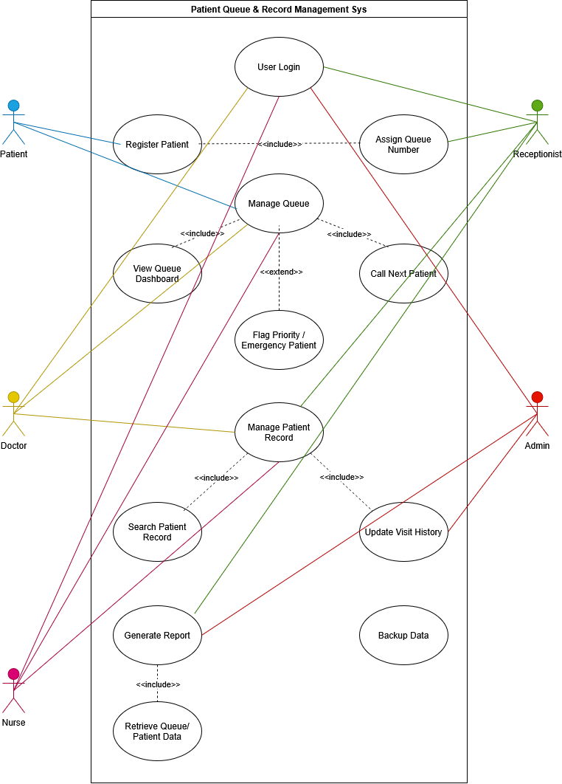

11. DETAILED USE CASE SPECIFICATIONS

Use Case Specification 1
Field | Details
Use Case ID | UC01
Use Case Name | User Login
Primary Actor | Authorised Staff
Other Actors | Clinic/Hospital Administrator
Purpose | Authenticate an authorised user before allowing access to system functions.
Trigger | User opens the application and submits login details.
Preconditions | Valid staff account exists.
Postconditions | User is authenticated and shown the appropriate system dashboard.

Related Requirements: FR01
Main Success Scenario:
Step | Actor Action | System Response
1 | Staff enters username and password. | System validates the credentials.
2 | Staff selects Login. | System checks the account.
3 | Staff provides valid credentials. | System authenticates the user.
4 | System determines the user's role. | System loads permitted functions.
5 | Staff views the dashboard. | System displays the relevant dashboard.
6 | Staff begins work. | System keeps the authenticated session active.

Alternative / Exception Flows:
Ref. | Condition / Alternative | Required Response
A1 | Invalid username or password | System rejects the login and asks the user to try again.
A2 | Required login field is empty | System prompts the user to complete the missing field.
A3 | Unauthorised access to restricted function | System denies access and keeps protected data unavailable.

Use Case Specification 2
Field | Details
Use Case ID | UC02
Use Case Name | Register Patient
Primary Actor | Receptionist / Front-Desk Staff
Other Actors | Patient
Purpose | Create or update a patient profile when the patient arrives.
Trigger | Patient arrives for service.
Preconditions | Receptionist is logged in and required registration information is available.
Postconditions | Patient profile is saved and the patient can proceed to queue assignment.

Related Requirements: FR02, FR03
Main Success Scenario:
Step | Actor Action | System Response
1 | Receptionist selects Patient Registration. | System opens the registration form.
2 | Receptionist enters patient details. | System validates the entered information.
3 | Receptionist submits the form. | System saves the patient profile.
4 | System creates the arrival record. | System prepares the patient for queue assignment.
5 | Receptionist confirms registration. | System displays confirmation.
6 | Patient proceeds to queue. | System makes the patient available for queue management.

Alternative / Exception Flows:
Ref. | Condition / Alternative | Required Response
A1 | Required information is missing | System highlights missing fields and prevents submission.
A2 | Patient already exists | System displays the existing profile and avoids unnecessary duplicate creation.
A3 | Invalid data format | System prompts the receptionist to correct the field.

Use Case Specification 3
Field | Details
Use Case ID | UC03
Use Case Name | Manage Queue
Primary Actor | Receptionist / Front-Desk Staff
Other Actors | Nurse / Clinician, Patient
Purpose | Assign, monitor and call patients in an organised queue.
Trigger | A registered patient arrives or the next patient is ready to be called.
Preconditions | Patient is registered and queue functionality is available.
Postconditions | Queue status is updated and the next appropriate patient is called.

Related Requirements: FR03, FR04, FR05
Main Success Scenario:
Step | Actor Action | System Response
1 | Receptionist adds patient to queue. | System assigns a queue number.
2 | Receptionist views queue. | System displays current queue order and waiting times.
3 | Receptionist/clinician flags priority if needed. | System marks the patient as priority/emergency.
4 | Staff selects next patient. | System identifies the next appropriate patient.
5 | Staff calls patient. | System updates queue status.
6 | Patient proceeds to service. | System records the queue progress.

Alternative / Exception Flows:
Ref. | Condition / Alternative | Required Response
A1 | Emergency case is identified | System highlights the patient for priority handling.
A2 | No patients are waiting | System displays an empty/idle queue state.
A3 | Patient is already served | System prevents the same queue entry from being called again.

Use Case Specification 4
Field | Details
Use Case ID | UC04
Use Case Name | Manage Patient Record
Primary Actor | Nurse / Clinician
Other Actors | Receptionist
Purpose | Retrieve and update a patient's digital record and visit history.
Trigger | Clinician needs the patient's history during a visit.
Preconditions | User is authorised and patient has a stored profile.
Postconditions | Patient information and updated visit history are saved.

Related Requirements: FR06, FR07, FR08
Main Success Scenario:
Step | Actor Action | System Response
1 | Clinician searches by name or ID. | System returns matching patient records.
2 | Clinician selects patient. | System displays the patient profile.
3 | Clinician reviews history. | System displays previous visits.
4 | Clinician records visit information. | System validates and prepares the update.
5 | Clinician saves changes. | System stores the updated visit.
6 | Clinician exits the record. | System retains the persistent history.

Alternative / Exception Flows:
Ref. | Condition / Alternative | Required Response
A1 | No matching patient found | System reports no match and allows another search.
A2 | User is not authorised | System denies access to protected records.
A3 | Required update information is missing | System requests completion before saving.

Use Case Specification 5
Field | Details
Use Case ID | UC05
Use Case Name | Generate Report
Primary Actor | Clinic/Hospital Administrator
Other Actors | Receptionist / Clinician
Purpose | Provide operational information about patient volumes and facility activity.
Trigger | Administrator requests an operational report.
Preconditions | Relevant patient/queue information exists and administrator is authorised.
Postconditions | Report is generated for review.

Related Requirements: FR09
Main Success Scenario:
Step | Actor Action | System Response
1 | Administrator opens Reports. | System displays available report options.
2 | Administrator selects a report. | System identifies required data.
3 | Administrator specifies the relevant period/type. | System validates the selection.
4 | Administrator requests the report. | System retrieves stored information.
5 | System calculates operational statistics. | System displays the report.
6 | Administrator reviews the report. | System keeps the report available for review.

Alternative / Exception Flows:
Ref. | Condition / Alternative | Required Response
A1 | No data exists for the selected period | System displays an empty-data message.
A2 | Invalid report selection | System prompts the administrator to select a valid option.
A3 | Insufficient permissions | System denies report access.

Use Case Specification 6
Field | Details
Use Case ID | UC06
Use Case Name | Backup Data
Primary Actor | Administrator / Project Team
Other Actors | Clinic/Hospital Administrator
Purpose | Create a local backup of project/system data to reduce risk of data loss.
Trigger | Administrator initiates a backup.
Preconditions | User has backup permission and a valid local backup destination is available.
Postconditions | A backup copy is created and confirmation is displayed.

Related Requirements: FR10
Main Success Scenario:
Step | Actor Action | System Response
1 | Administrator opens Backup. | System displays backup options.
2 | Administrator chooses backup location. | System checks the destination.
3 | Administrator starts backup. | System copies the required data.
4 | System validates the backup operation. | System confirms successful completion.
5 | Administrator reviews confirmation. | System records/displays the backup result.
6 | Administrator closes backup function. | System returns to the dashboard.

Alternative / Exception Flows:
Ref. | Condition / Alternative | Required Response
A1 | Backup destination unavailable | System reports the error and requests another destination.
A2 | Backup fails during copying | System reports failure without claiming the backup is complete.
A3 | User lacks permission | System denies the backup operation.

Figure 4. Activity Diagram — Reporting and Backup
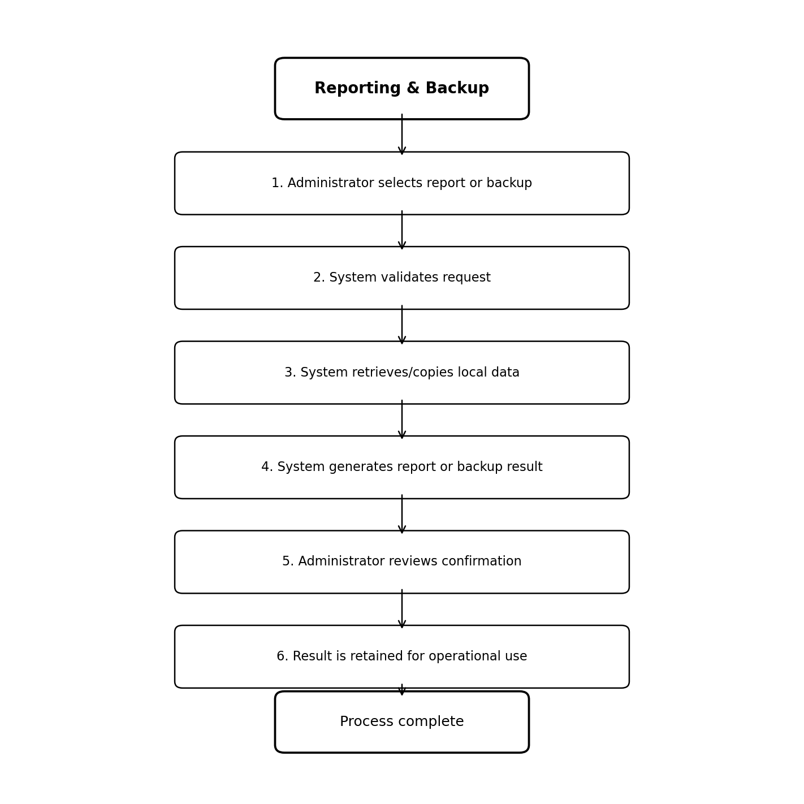
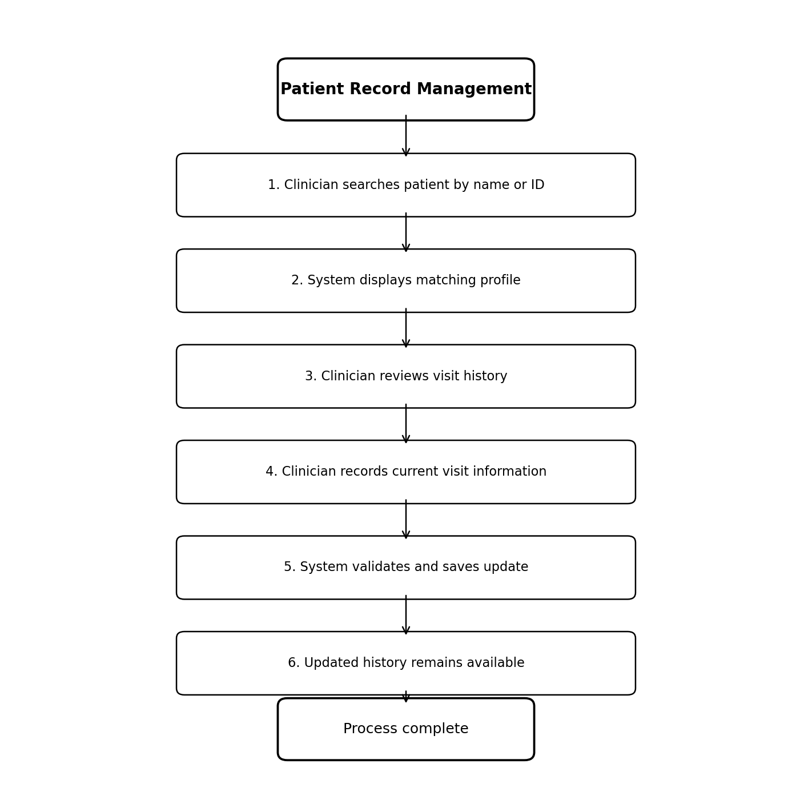
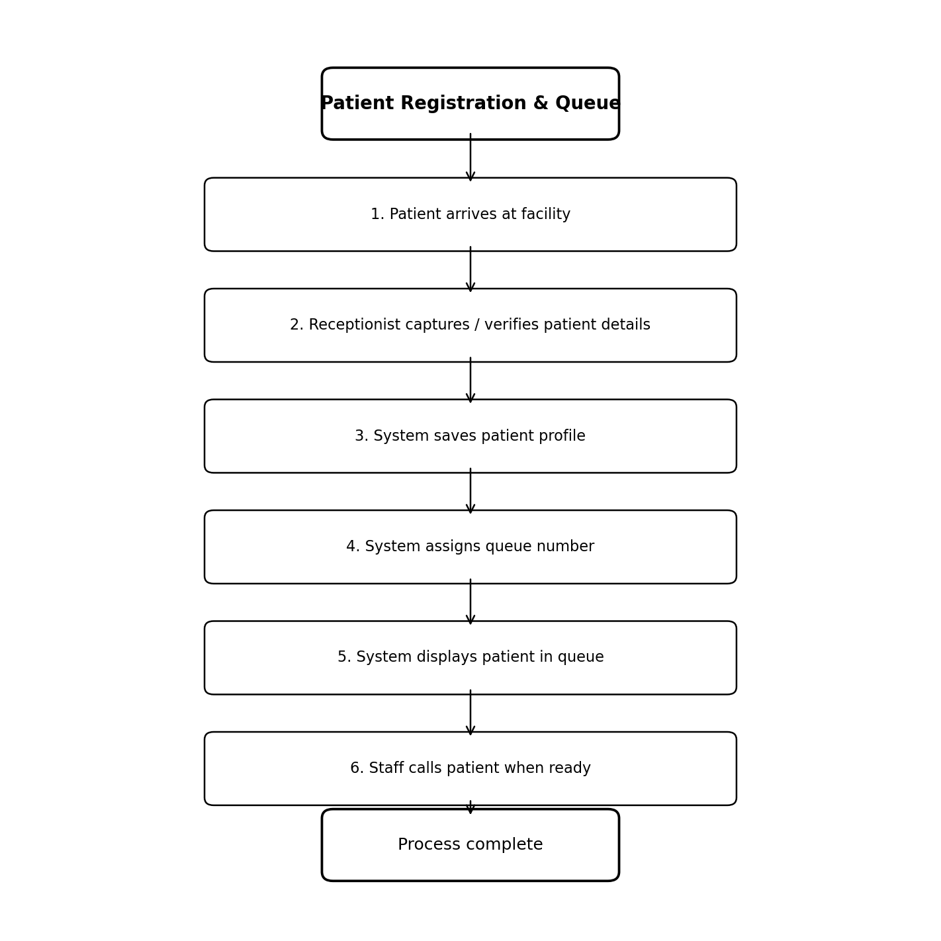

12. ACTIVITY DIAGRAMS
[INSERT ACTIVITY DIAGRAM 1 HERE]
[INSERT ACTIVITY DIAGRAM 2 HERE]
[INSERT ACTIVITY DIAGRAM 3 HERE]

13. DATA / INFORMATION REQUIREMENTS
Information Requirement | Description | Used By / Process | Important Data Required
Patient Profile | Core demographic/contact information used to identify a patient. | Registration and patient record management | Patient ID, name, contact details, relevant profile information
Queue Entry | Information about a patient's current place in the service queue. | Queue management | Queue number, patient ID, arrival time, status, priority/emergency flag
Visit History | Persistent record of a patient's previous visits and updates. | Patient record management | Patient ID, visit date, visit information, relevant history
User Account | Information needed to authenticate and authorise staff. | Login and access control | Username, password/credential data, role
Operational Statistics | Stored information used to support facility reports. | Report generation | Patient volumes, queue activity, waiting-time information
Backup Data | A local copy of system data for recovery. | Data backup | Database/system data and backup location/date

14. REQUIREMENTS TRACEABILITY MATRIX
Requirement ID | User / Stakeholder Need | Related Use Case | Related Business Rule(s) | Priority
FR01 | Authorised staff need controlled access. | UC01 | BR01 | High
FR02 | Receptionist needs fast patient registration. | UC02 | BR04 | High
FR03 | Receptionist needs automatic queue assignment. | UC03 | BR02 | High
FR04 | Staff need visibility of queue order and waiting times. | UC03 | BR03 | High
FR05 | Staff need to identify priority/emergency cases. | UC03 | BR03 | Medium
FR06 | Clinicians need accessible digital patient records. | UC04 | BR01, BR04 | High
FR07 | Clinicians need persistent visit histories. | UC04 | BR04 | Medium
FR08 | Clinicians need search by name or ID. | UC04 | BR05 | Medium

15. UPDATED FEATURE BACKLOG
Feature ID | Feature / Work Item | Related Requirement(s) | Priority | Current Status
F01 | User Login | FR01 | High | Planned
F02 | Patient Registration | FR02 | High | Planned
F03 | Queue Number Assignment | FR03 | High | Planned
F04 | Queue Dashboard | FR04 | High | Planned
F05 | Patient Record Management | FR06, FR07 | High | Planned
F06 | Priority / Emergency Flagging | FR05 | Medium | Planned
F07 | Visit History Tracking | FR07 | Medium | Planned
F08 | Report Generation | FR09 | Medium | Planned

The analysis translates the Apex project proposal into a structured system-analysis specification. The proposed system addresses the identified problems of manual registration, disorganised queues, long waiting times and difficult access to patient records. The defined requirements and business rules provide a basis for design, implementation and testing. The scope remains appropriate for a Year 2 academic project because it focuses on a Windows desktop application, local data storage and core patient-flow functions while excluding mobile, cloud and national-system integrations.

APPENDIX A. PROJECT ACTIVITY AND CONTRIBUTION RECORD
Project Activity / Task | Responsible Member(s) | Expected Output | Date Assigned | Due Date | Status
Requirements analysis | Mdubo N | Requirements, scope and use cases | To be confirmed | To be confirmed | Planned
Project planning and coordination | Mntungwa ST | Project schedule and coordination | To be confirmed | To be confirmed | Planned
Application development | Jongihlati SA | Working application features | To be confirmed | To be confirmed | Planned
System testing | Mathebula A | Test results and defect reports | To be confirmed | To be confirmed | Planned
Documentation | Zulu Y | Project documentation | To be confirmed | To be confirmed | Planned
UI/UX design | Khwela JM | Interface design and layouts | To be confirmed | To be confirmed | Planned
Team review | All team members | Reviewed system-analysis document | To be confirmed | To be confirmed | Planned
Final submission preparation | All team members | Final integrated project submission | To be confirmed | To be confirmed | Planned

